Entering a Quote
- Go to Enter & Edit Orders
- Hit enter to create unique quote number
- Ensure that the Order Type is “Quote”
- Fill out all the required fields
  - The field titled Customer PO# will show up as RFQ# on the quote document. This can be used to enter an actual RFQ# or the name of the project you are quoting.
  - Make sure to enter a contact name, if contact is not in the system please create the new contact.
    - 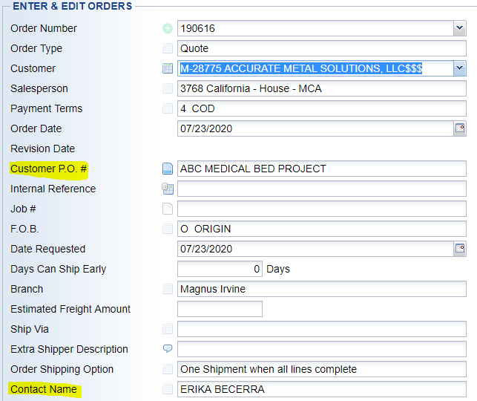
- Hit OK
- Enter product code and fill out required fields (If you are quoting a product that is not already in the system jump to step 9)
  - Use Line Comment Text box to enter Lead Time for item
  - 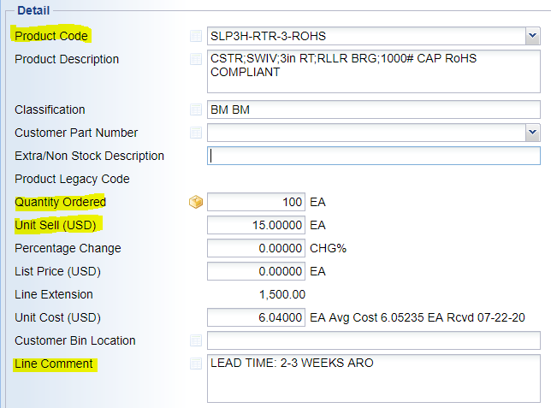
- Hit OK
- Click on “New Line” to enter another item and follow step 6.
- *If a part number is not in the system you can create a temporary part number.
  - Type in “New” as the product code
  - In the Extra/Non Stock Description field enter the part number you would like to quote
  - In the line comment section enter the description of the part number
  - In the Internal Comment section enter our internal cost, vendor information, price breaks, and the vendor part number if different from quoted part number.
  - 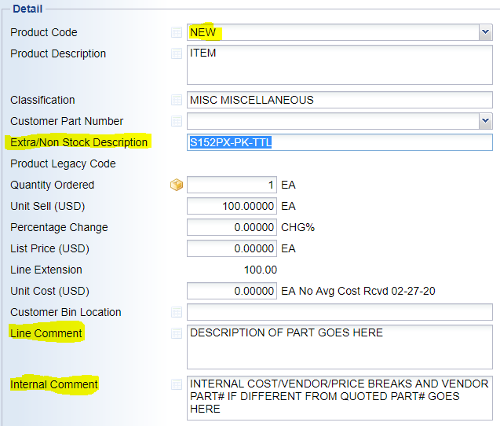
- Once you have entered all the items you would like to quote click OK on the detail lines page.
- This is the final quote page, if you would like to add any additional messages to the quote go to Options and choose Order Messages.
  - 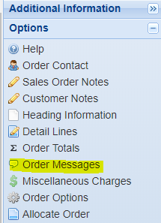
  - Use the Final Message and Quote Message sections to full out any additional information you would like to include on the quote.

- Once all information is entered and you would like to email your customer the quote, go to Options > Output Options > Output Order/Quote
  - 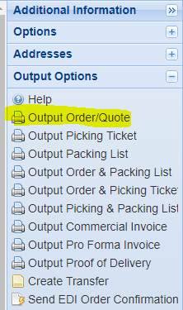
  - Change Output Options to Email
    - 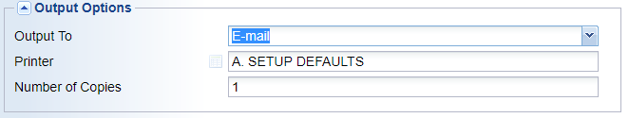
    - Click OK
  - You can email yourself a copy of the quote to review, and then copy and paste the quote in an existing email thread by choosing E-mail Myself.
    - 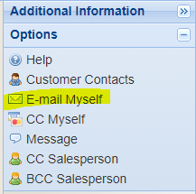
  - Before emailing the quote highlight and copy the Quote# shown on the subject line then click on the + sign on the CRM Actions window.
    - If you do not see this window go to optional information on the bottom left and make sure this window is checked
      - 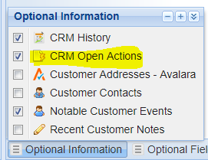
  - Click on New Line then enter required information as shown in the CRM Training Manual.
  - Make sure to choose “Quote Follow Up” as the Action Type and paste the Quote number in the Action Subject.
  - Click OK.
  - Click OK again to email yourself the quote
  - Click OK one last time to close out the quote.

