TBE- CRM Workflow

- Inbound Call
  - Go to Customer Inquiry and enter customer name
    - Click on CRM Actions under the Options Menu on the right
      - 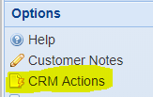
    - Click on New Line
    - Enter contact name
      - If contact is not in the system go to Options, choose Customer Contacts, and New Line to enter the contact into the system.
        - 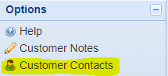
    - Choose an Action Type
      - Click space then enter to see list of available Action Types and choose one.
    - Enter Action Subject
    - Enter notes/details of conversation in the Action Description box
  - Click on Create Follow Up (This will convert the notes of your conversation into CRM History and automatically create your next CRM Open Action).
      - 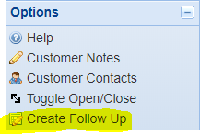
    - Enter Follow up Action Type, Subject, and Description
      - The Action Description should provide details of what action needs to be taken. i.e.- “Send quote on 100pcs- of part# XYC”
    - Pick date and time for follow up
    - Choose Notification if needed
    - If someone else needs to take action, assign the action to the correct person by clearing your name from the “Assigned to” box, hit space then enter and choose the person you want to assign the task to.
      - Please make sure to set a notification when assigning a task so the person receives a reminder of the assigned task.
- Daily Outbound Calls (Once Action list is created)
  - Go to Inquiries > CRM Action Inquiry
    - 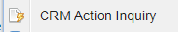
  - Enter Dates
    - Begin: Enter 1/1/19
    - End: Enter “T” or today’s date
      - If you want to see more actions into the future enter a later date
  - Make sure the User Field has your name, if not enter your user name.
  - Leave Customer and Contact field blank
  - Action Status: Open
  - Action User Type: Assigned To
  - 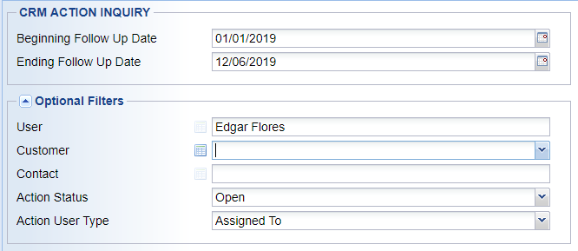
  - Hit “OK”
  - A call list will be created with oldest action first
    - Search function can be used for finding customer or high priority actions
  - Double click on action to complete and make the call
  - After the call enter notes from the call in the Action Description field
  - Once notes from call are entered, click on Create Follow Up and follow instructions listed above in section 1.b.
  - *If no further action needed (no potential/out of business) click on Toggle Open/Close to close the Action without creating a new Action
    - 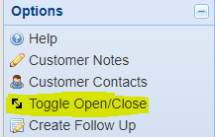
  - After you click “OK” you will return to the call list you created. Go on to next action and repeat steps above. *Please note that the call list will not update unless you rerun the CRM Action Inquiry, you can do this by hitting the OK button twice.
- Quote Follow Up
  - Once you have completed a quote on the final page go to Output Options and choose Output Order/Quote
    - 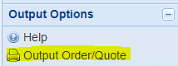
  - Choose email under Output to: and click OK
  - Before emailing the quote highlight and copy the Quote# shown on the subject line then click on the + sign on the CRM Actions window
    - If you do not see this window go to optional information on the bottom left and make sure this window is checked
      - 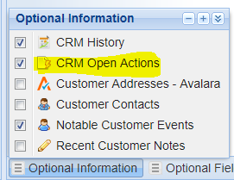
  - Click on New Line then enter required information as stated in section 1.a.
  - Make sure to choose “Quote Follow Up” as the Action Type and paste the Quote number in the Action Subject.
  - Click OK.
- On Site Visit
  - Create Action for appointment as shown in section 1.a.
  - Once visit is over and back at your computer run CRM Action Inquiry as stated above, follow steps 2.a. through 2.l.
  - For New Customer Visits/Cold Calls where the customer is not in the system you will have to enter the customer and contact in E&E Customers as a prospect or lead before creating a CRM Action.

