Entering a Lead or Prospect
- Go to Master Files > Enter & Edit Prospects
- Hit Enter to create a unique customer code
  - Please make sure that you have searched in Customer Inquiry before this step to ensure this customer is not already in the system.
- Enter in Required information
  - Company Name
  - Contact
    - 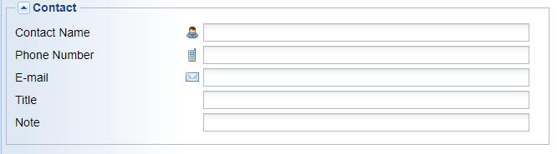
  - Address
    - 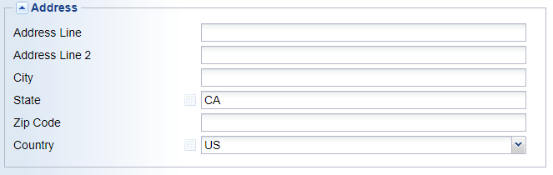
  - Profile Information
    - 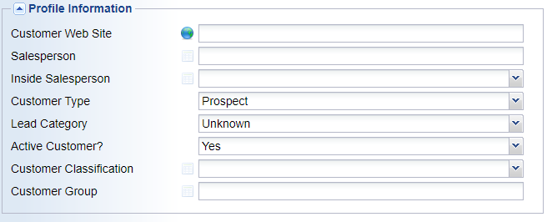
    - Choose either Prospect or Lead as Customer Type
      - Prospect= Field Sales generated target account
      - Lead= Lead generated by marketing or outside sources
    - You must leave Active Customer as “Yes”. Do not change.
    - Customer Classification
      - Make sure to choose a classification do not just leave it as Unassigned
- Once required information is entered click OK and the Lead or Prospect has been created.
- You can also add a CRM Action, add additional contacts, or a customer note before getting out of this page using the options on the right hand of the page.

