Time Off Procedure

To Request time off:
On the Home screen, use
Myself tab
Time Off
Request Time Off
Block the days requested off – this will take you to the screen below
Enter the start and end date(s)
If you need to edit for a partial day – there is an edit button
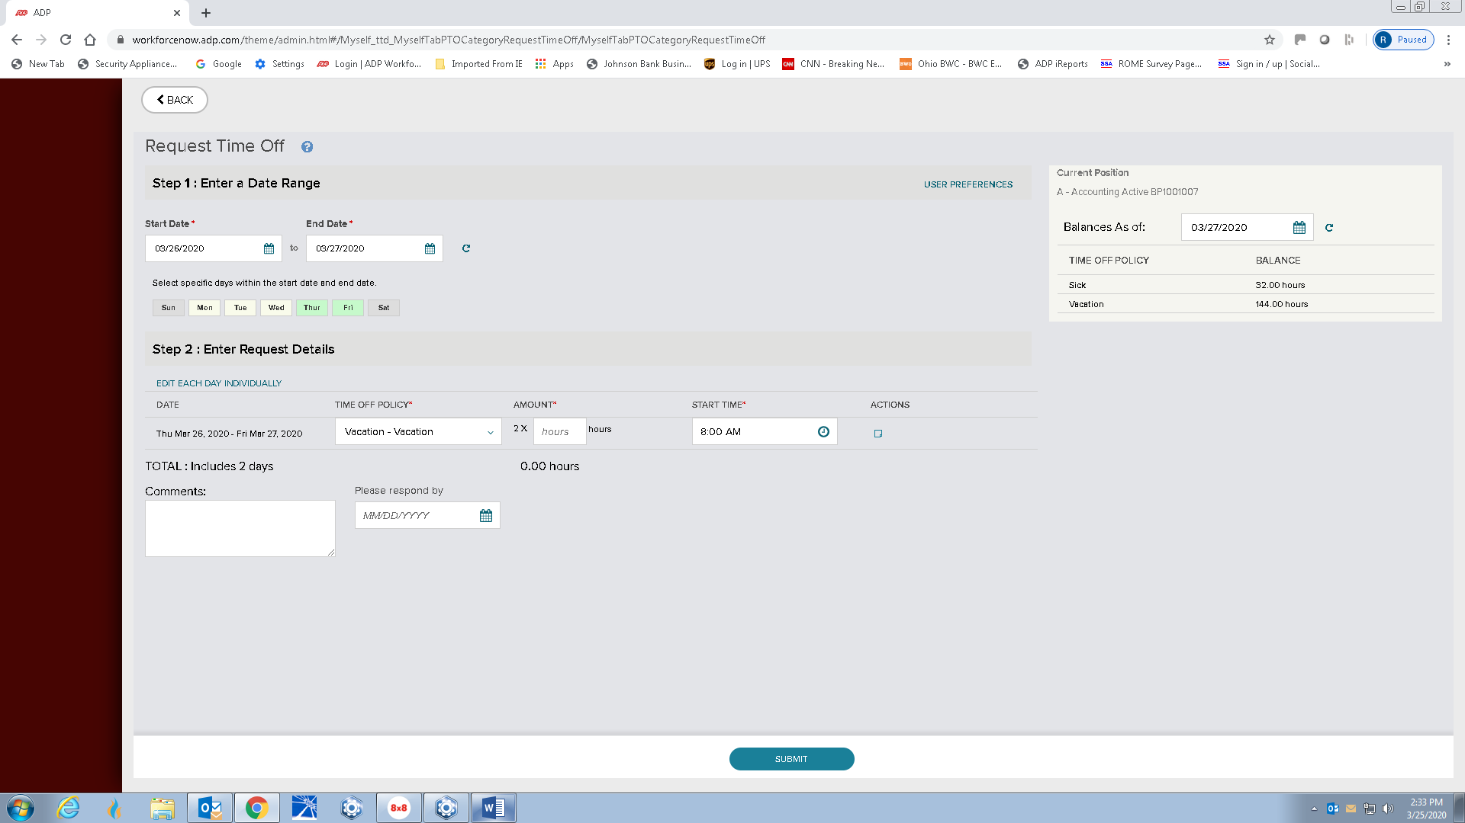

Enter the total number of hours requested.
Click done if all looks correct.
The request is sent to the supervisor.

Supervisors
On the main screen, very top, is the messages envelope.
Check this for requests.
Approve or do not approve.
To see scheduled, Use:
My Team
My team calendar

