TBE Customer Sales Order Acknowledgement Condensed Procedure
For the complete, detailed procedure, please see the TBE Customer Sales Order Acknowledgement Procedure
All customer sales orders to be acknowledged within 24 hours, when possible.
Please reference the TBE PO Confirmation Procedure as the precursor to this procedure.
Screen: Enter & Edit Orders
- Take the confirmed delivery date by our supplier and if it is different than the original Date to Ship that was entered on the sales order, it should be changed to the new date at this time. If there are scheduled lines, make sure to change the dates on those lines as well. See below.

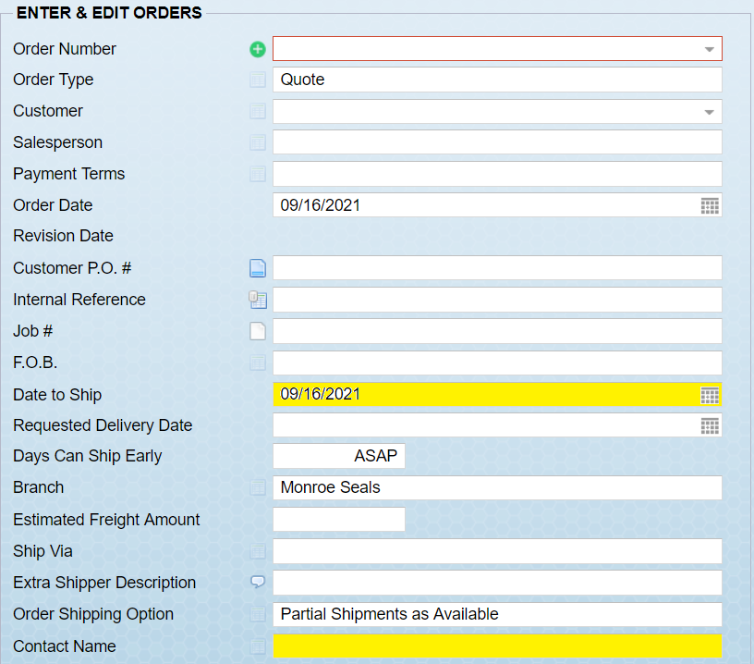
- After all of the edits have been made to the sales order, it is now time to send the acknowledgement to the customer. Go to the Output Option on the main E&E Orders screen(see below), and choose Output Order/Quote.
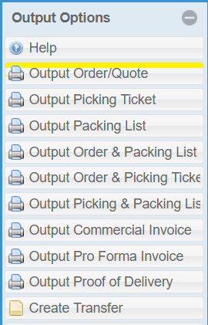

- On the Print Quote screen, choose the output of E-mail(see below)
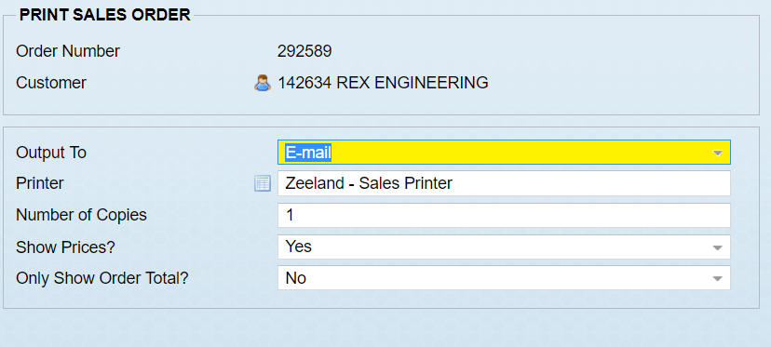

- On the next screen, choose the customer contact to e-mail the acknowledgement to and copy yourself.

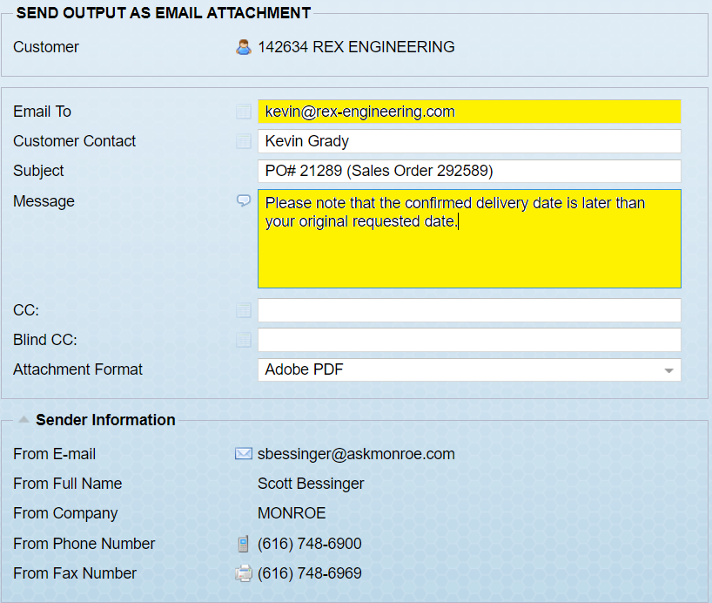

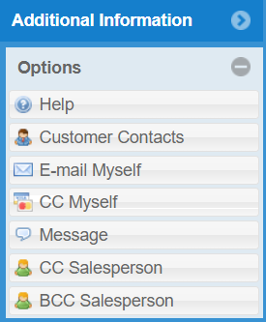

- Hit “Okay” in the bottom right-hand corner and the order confirmation will be sent.

