TBE Customer Sales Order Acknowledgement Procedure

It is recommended practice that all customer sales orders be acknowledged back to the customer with a confirmed delivery date. The acknowledgement goal is to send confirmations within 24 hours after the customer order is placed. When that is not possible, it needs to be done as soon as we have confirmation back from our supplier.
Please reference the TBE PO Confirmation Procedure as the precursor to this procedure.
Screen: Enter & Edit Orders
- After Purchasing receives delivery confirmation from our supplier, the sales order is returned to Order Entry/Customer Service/Sales for customer acknowledgement. The confirmed delivery date(s) are noted on the Customer Sales Order by Purchasing, so Order Entry/Customer Service/Sales can easily identify them.
- When the customer sales order was originally entered, the contact name of the customer representative placing the order with us should have been entered in the Contact Name field on the main E&E Order screen. See below. If the contact name is not in the field, it should be entered at this time. It is expected that salespeople enter all customer contacts in the customer database under the contacts field, along with a valid e-mail address. If this contact does not have a valid e-mail address, it should be entered in E&E Customers, under the contact field, at this time.
- If the confirmed delivery date by our supplier is different than the original Date to Ship that was entered on the sales order, it should be changed to the new date at this time. See below.

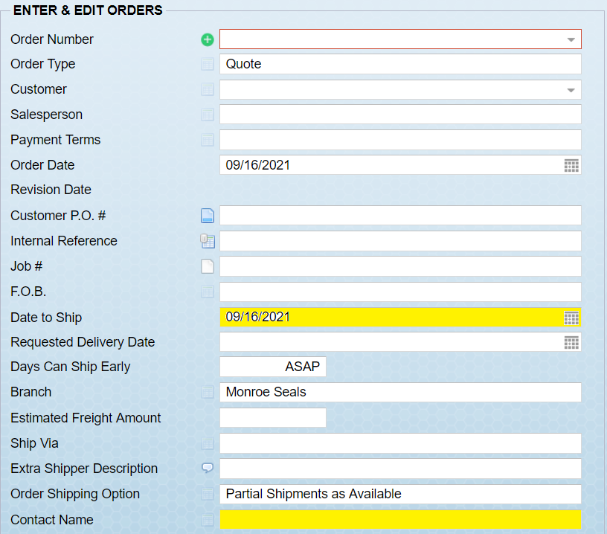
- If the sales order has scheduled lines and the confirmed date(s) from our supplier are not the same as the original ship dates on the scheduled lines, then go in and change those dates on each scheduled line at this time.
- After all of the edits have been made to the sales order, it is now time to send the acknowledgement to the customer. Go to the Output Option on the main E&E Orders screen(see below), and choose Output Order/Quote.
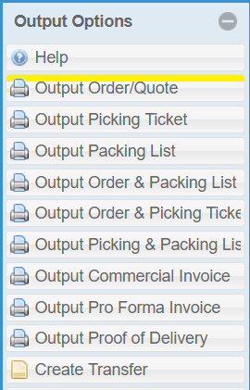

- On the Print Quote screen, choose the output of E-mail(see below)
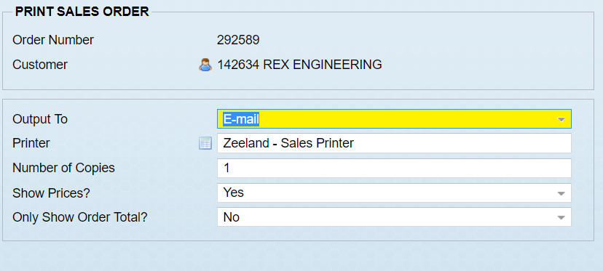

- On the next screen, choose the proper customer contact by clicking on the calendar icon to the left and then choosing the customer contact from the list of contacts for that customer in TBE. This will populate the field. If the customer contact and e-mail address is not in the system, you can either go back to step 2 or if you know their e-mail address, you can manually enter it here. Then you can add a note if you wish. I have entered an example of the type of note you may want to enter. If anyone needs to be copied, you can do that at this time as well. I would suggest copying the account manager for that customer if the date has changed more than 2-3 days from the original date. This can easily be done by choosing CC Salesperson in the options box to the right(see second image below), or you can copy yourself, in case you want to review what the customer ended up seeing. This also gives you verification that the acknowledgement was sent properly.

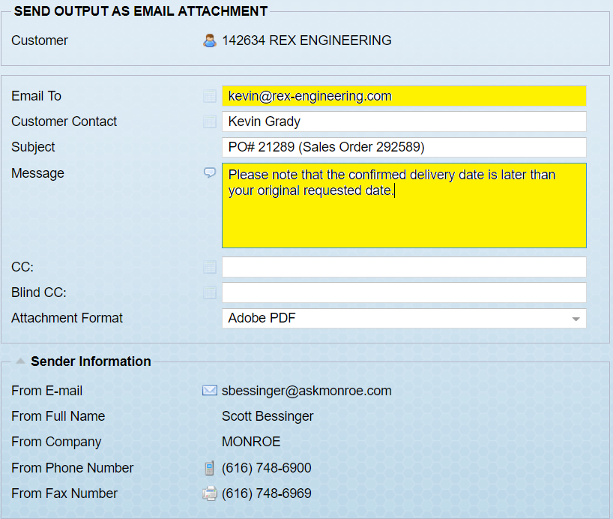

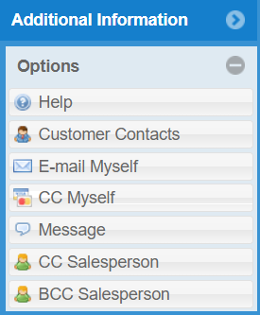

- Hit “Okay” I the bottom right hand corner and the order confirmation will be sent.

