TBE PO Confirmation-Condensed
For the complete detailed procedure, please see the TBE PO Confirmation procedure.
Screen: E&E Purchase Orders
Heading Screen:
- Enter the PO Number in the first field
- Enter the Vendor Sales Order number if the vendor provides it. If it’s not available, enter the name of the person you emailed with or spoke to when confirming the PO.
- Change the Original Promised Date & the Current Promised Date to the date it is due to arrive at the branch.
- Click OK to move to the next screen.
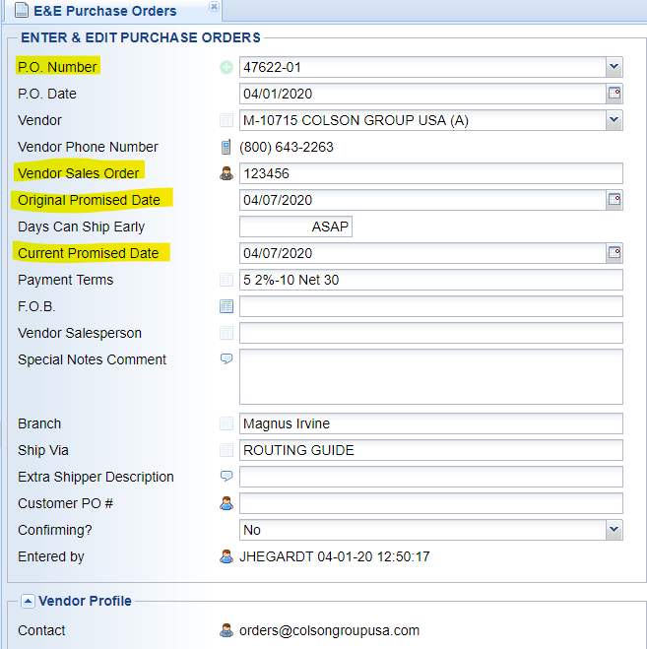
Detail Lines Screen:
- Double click on any individual item that needs to have notes added or dates changed to move into the PO Line
PO Line Screen:
- Change any pricing, individual dates if needed.
- To add internal notes (notes that don’t show up on the PO – for internal use only) click on the Line Comments under Additional Information - #1 Options.
- In the Internal Comment field add a note.
  - Note should have the date you added the note, your initials, and important information. EX. “4/1/20 JEH – Per email/Enrique PO shipping 4/6/20.”
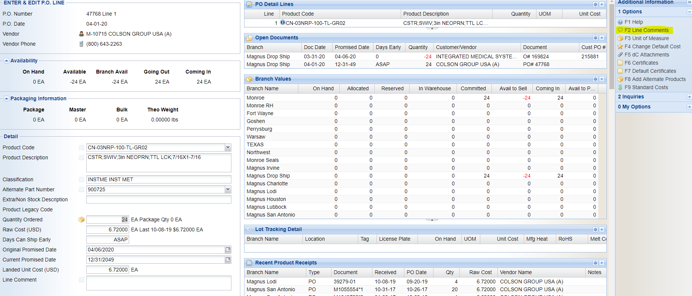

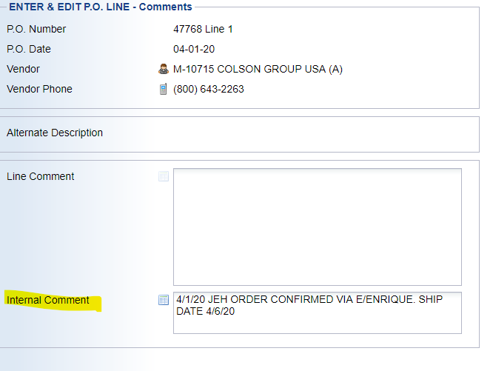

Final Screen:
- Once all the items have been updated and notes have been added as needed, click Changed Confirmed under Additional Information – #1 Options. This updates the PO status to “confirmed” and removes this PO from the list of unconfirmed POs.
Updating a Confirmed PO:
When updating a PO that had already been confirmed, add notes with the details to the Internal Comment field. If the due date has changed and the PO is late, only change the Current Promised Date. This will let everyone see that the Current Promised Date is different than the Original Promised Date, showing that the PO/Vendor is late.
How to find Unconfirmed POs:
Use the screen Open P.O. Not Confirmed List to generate a report of unconfirmed POs by location. This report lists every open PO that has not been marked “Changed Confirmed”.
This report can be found in the Purchase Order System >Purchase Order Reports > Open P.O. Reports.

