TBE PO Confirmation
Screen: E&E Purchase Orders
Heading Screen:
- Enter the PO Number in the first field
- Enter the Vendor Sales Order number if the vendor provides it. If it’s not available, enter the name of the person you emailed with or spoke to when confirming the PO.
- Change the Original Promised Date & the Current Promised Date to the date it is due to arrive at the branch.
  - If there are multiple items arriving at different times, change these dates to the dates that the last item is due to arrive at the branch. The other items will be changed individually on the next screen.
  - If the ship date confirmed by the vendor is longer than the vendor “standard lead time” or different than the note/quote referenced on the PO by more than 2 – 3 days, notify the sales order taker with the discrepancy via email.
    - Note: PO dates (pre-confirmation) will be based on the vendor “standard lead time” (see document) or the quoted lead time noted on the PO.
  - Each branch may handle notifying the customer of the confirmed delivery date differently. Please see the TBE Customer Sales Order Acknowledgement Procedure for the alternate process. This procedure requires that all customer orders be acknowledged.
  - Salespeople are expected to notify the buyer with special pricing or lead time from a vendor via email before the PO has been placed. A quote # or name of the person who quoted must be referenced.
  - In the case where vendor pricing and/or delivery do not match the customer order, salespeople are expected to notify their buyer with any changes and receive a revised sales order or confirmation of acceptance from the customer before the PO will be revised to the vendor.

- Click OK to move to the next screen.
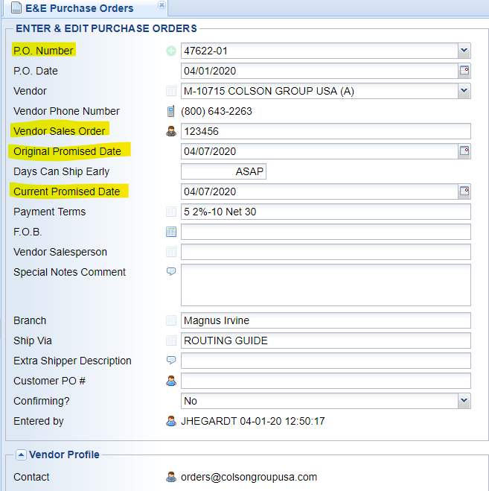
Detail Lines Screen:
- Double click on any individual item that needs to have notes added or dates changed to move into the PO Line
PO Line Screen:
- Change any pricing, individual dates if needed.
- To add internal notes (notes that don’t show up on the PO – for internal use only) click on the Line Comments under Additional Information - #1 Options.
- In the Internal Comment field add a note.
  - Note should have the date you added the note, your initials, and important information. EX. “4/1/20 JEH – Per email/Enrique PO shipping 4/6/20.”
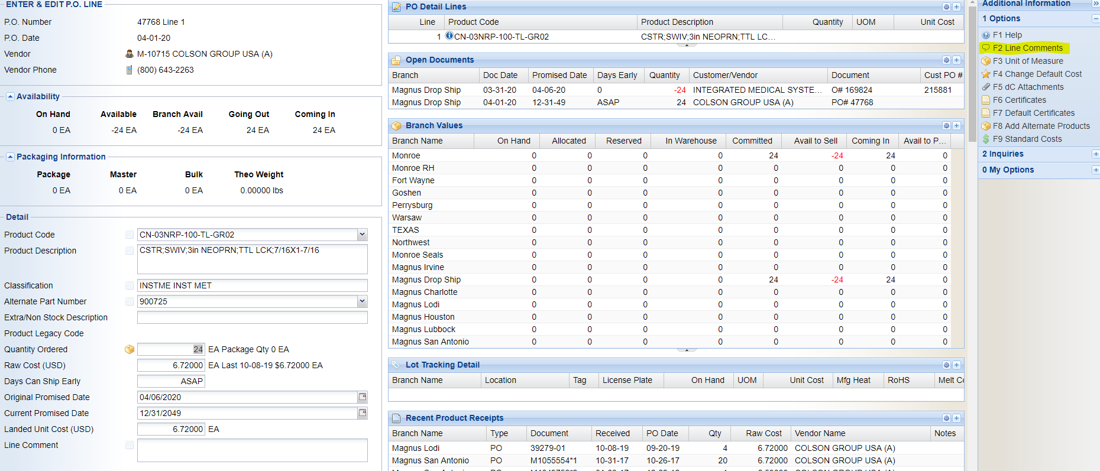

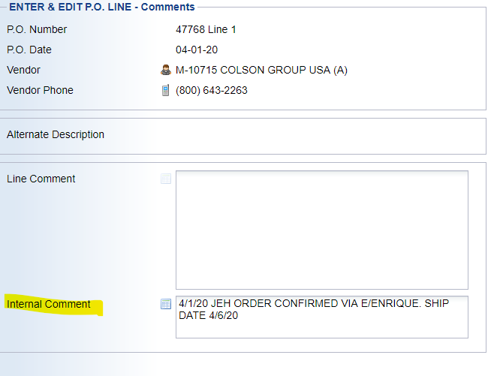

Final Screen:
- Once all the items have been updated and notes have been added as needed, click Changed Confirmed under Additional Information – #1`Options. This updates the PO status to “confirmed” and removes this PO from the list of unconfirmed POs.
Updating a Confirmed PO:
When updating a PO that had already been confirmed, add notes with the details to the Internal Comment field. If the due date has changed and the PO is late, only change the Current Promised Date. This will let everyone see that the Current Promised Date is different than the Original Promised Date, showing that the PO/Vendor is late.
Send an email to the sales order taker with information about the PO change so they can notify their customer and update the sales order date. Follow the TBE Customer Sales Order Acknowledgement Procedure.
It is recommended practice that each group follow the TBE Purchase order Expediting Procedure, but it is not a requirement.
How to find Unconfirmed POs:
Use the screen Open P.O. Not Confirmed List to generate a report of unconfirmed POs by location. This report lists every open PO that has not been marked “Changed Confirmed”.
This report can be found in the Purchase Order System >Purchase Order Reports > Open P.O. Reports.

