TBE Purchase Order Expediting Procedure-Condensed
For the complete detailed procedure, please see the TBE Purchase Order Expediting Procedure
Perform this procedure weekly, or bi-weekly.

Late Documents Report – run the late documents report
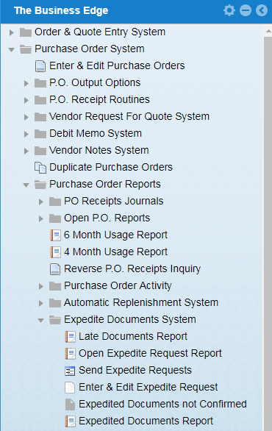

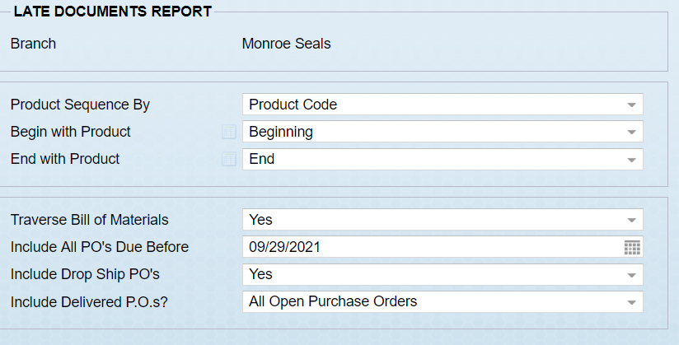

The next screen represents the results of running the Late Document Report.

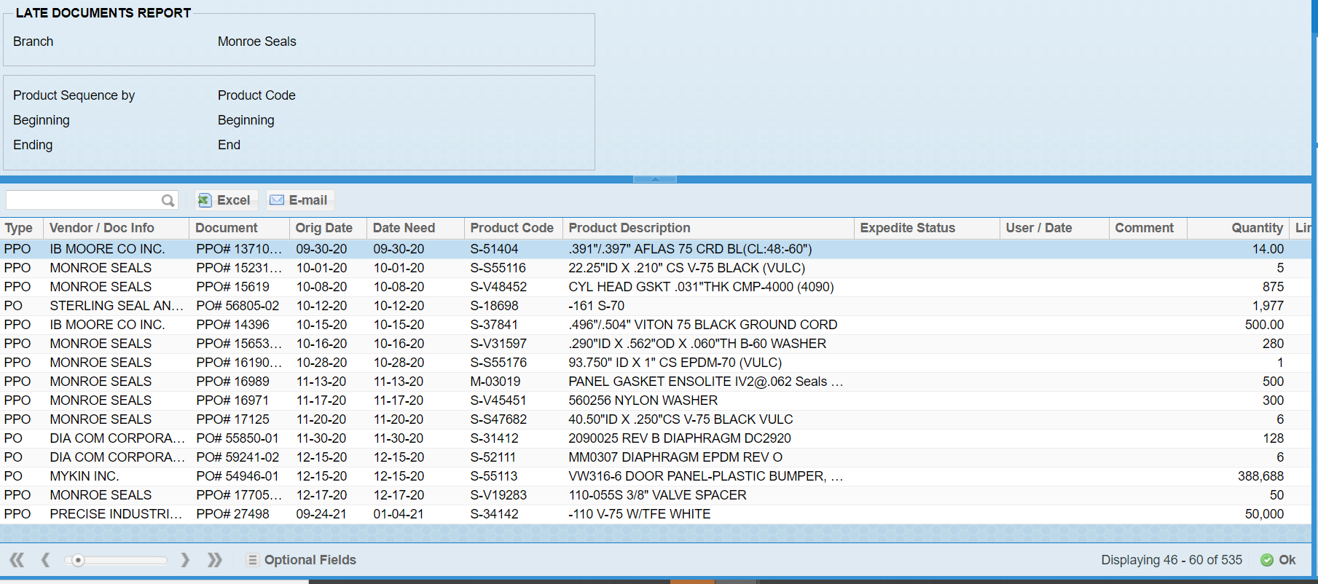

Double click on each line you would like to expedite.

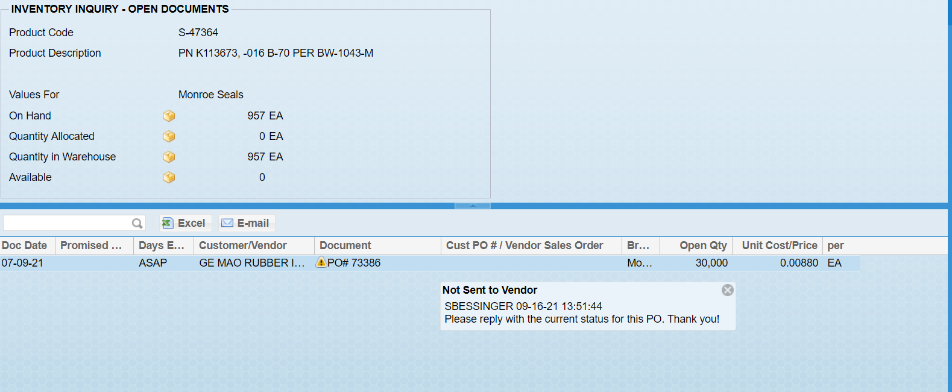

The escape key or OK will bring you back to the late documents report.

The screen below shows the result of double clicking the Purchase Orders you would like to expedite.

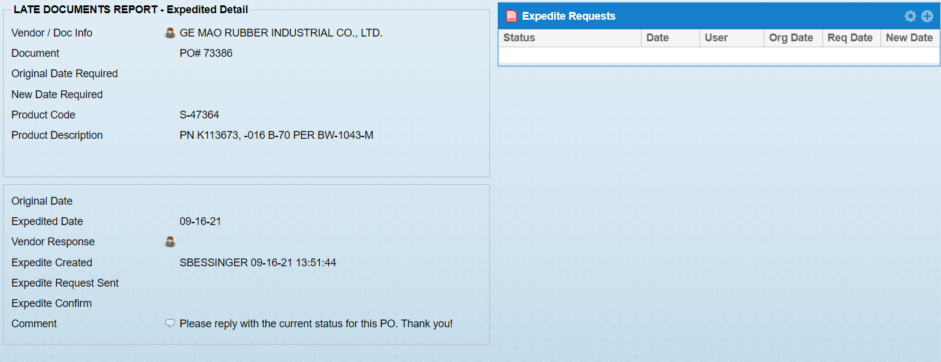

Yellow icons indicate the expedite request has not yet been sent to the vendor. Red icons indicate the request has been sent and you are waiting for a response.

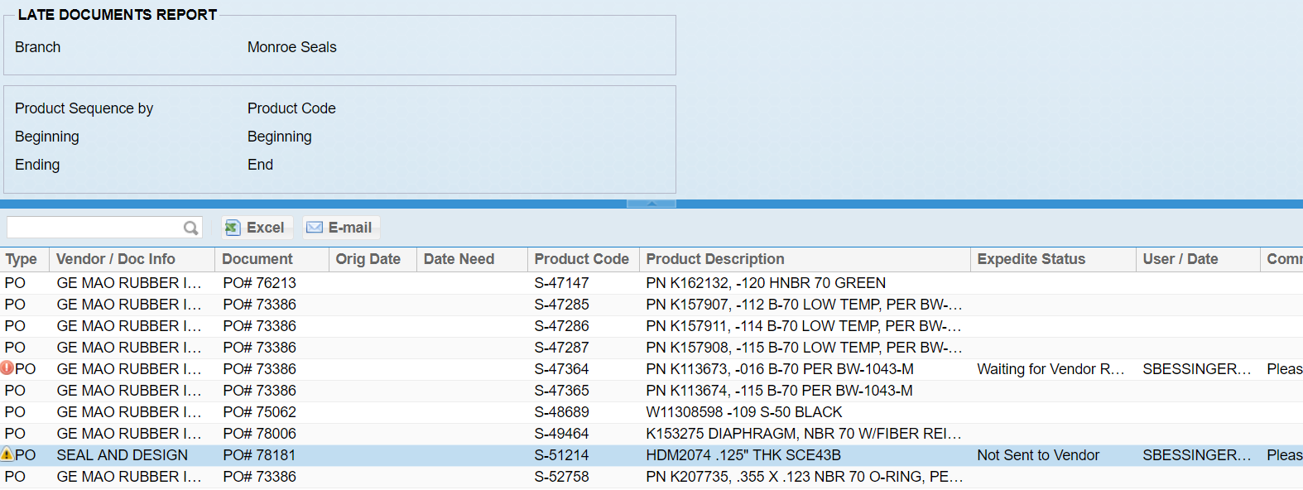

Send your expedite requests. This is done by clicking on Send Expedite Requests shown below. It is from this menu item that you can select whether you would like to print/fax/email your expedite requests to your vendor. We have found it is sometimes quicker and easier to contact the vendor manually, by direct e-mail or phone.

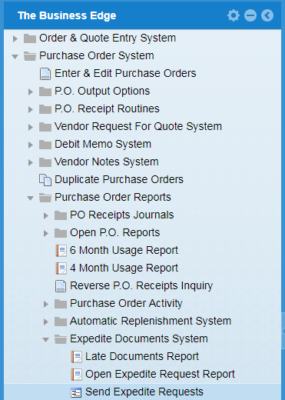

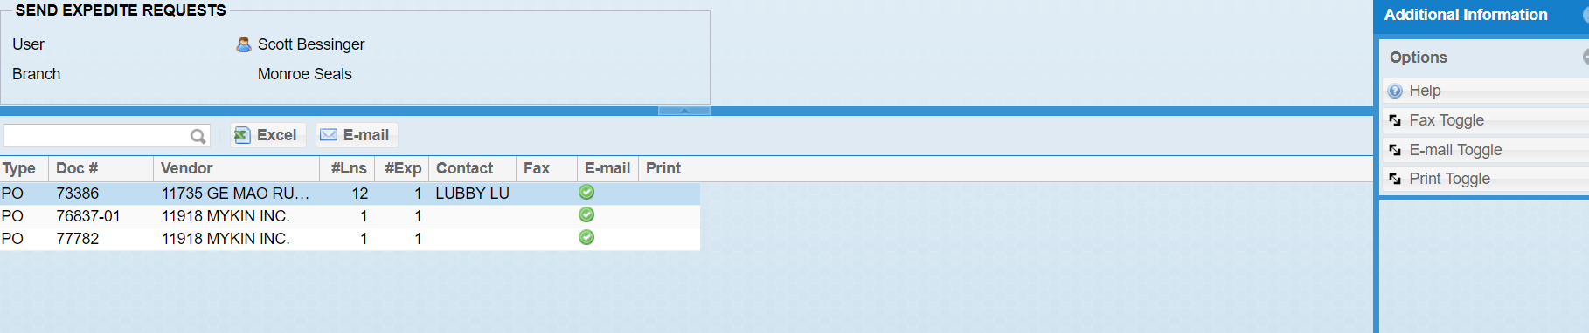

Send expedite requests one by one or in bulk. You cannot send them in bulk if any of the PO’s do not have contacts with e-mail addresses associated with them.

To send them individually, double click on the line and you will see the below screen

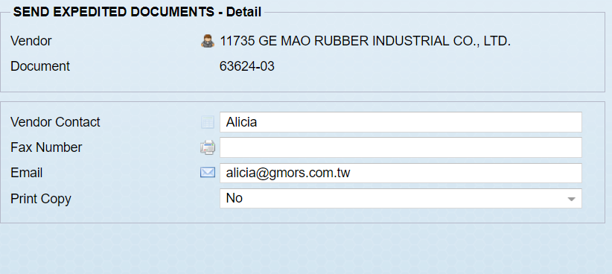

To send all your requests at once, just hit OK in the above “Send Expedite Requests” screen and you will get the next screen, as per below

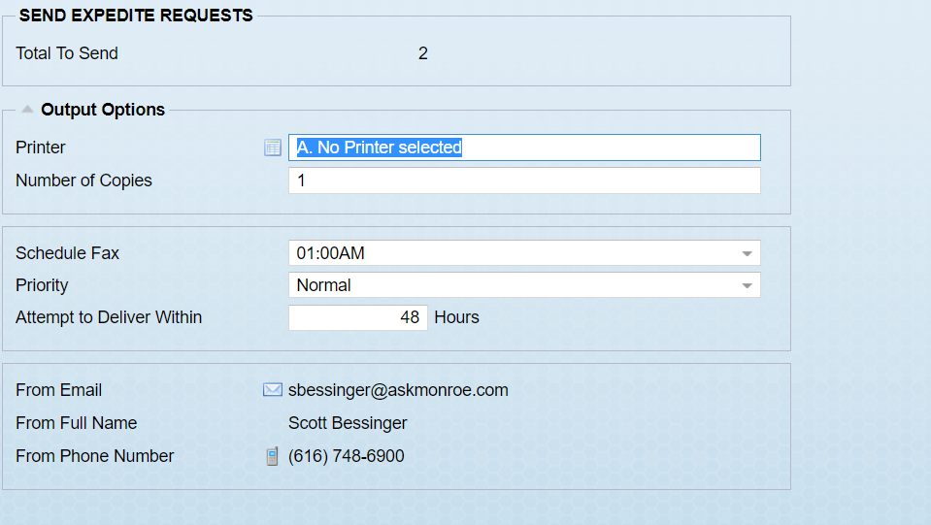

Set your output options and hit OK in the bottom corner. The requests will be sent at the time specified.

You can monitor your requests by running the Expedited Documents not Confirmed report below.
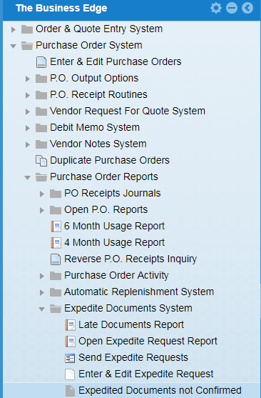

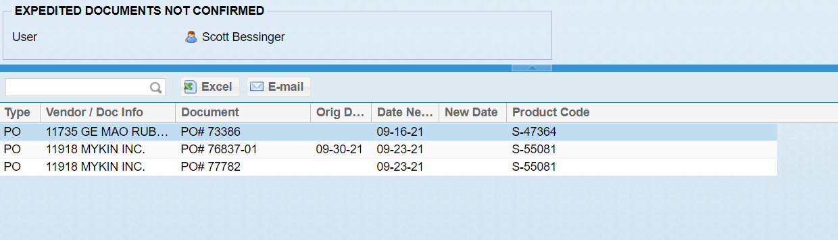

Double click on the line you want to add a new confirmed expedite date to. Add the new date and any vendor comments.

