TBE Purchase Order Expediting Procedure

This procedure is a recommended practice for each Monroe branch, but it is not a requirement.
This procedure should be performed weekly or every other week. Make sure to expedite parts far enough in advance as to not cause your customer difficulty if there is a problem with delivery. This will allow enough advance notice that something can be done before it is too late. Run the late documents report for everything that is past due and will be coming due in the next 3 months.

Late Documents Report
This report is designed to show you a list of Products on open Purchase Orders and Processing Purchase Orders that are needed to satisfy needs on Sales Orders and Processing PO’s or are late based on the Promise Date in the PO Detail Line.

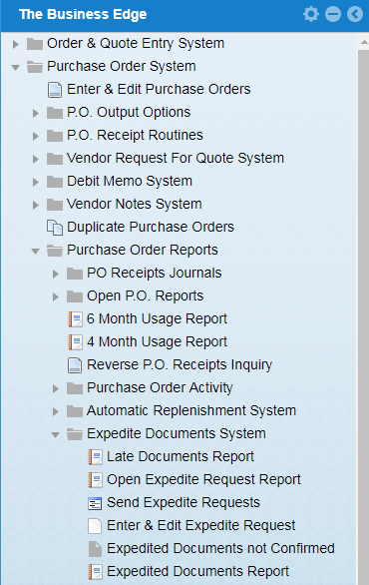

The screen below shows you the parameters you can use to run the Late Documents report. When you answer Yes to Traverse Bill of Materials the system will also prompt you to expedite components for PPO’s.

This report will take a good 10 to 15 minutes to run, but after it is done, you will only get the open PO’s and PPO’s, for your branch, that are past due or due within the date parameter that you have set.

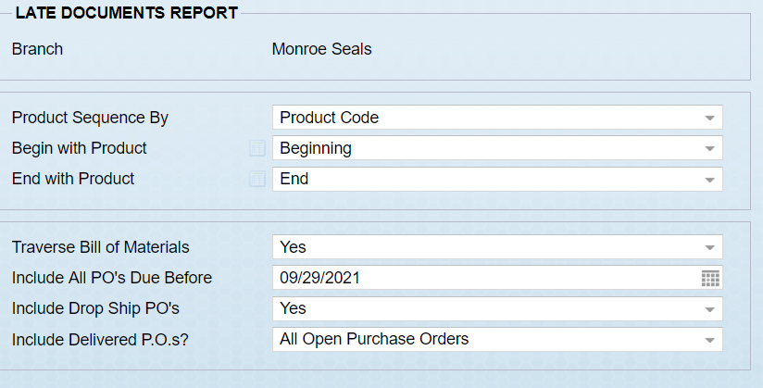

The next screen represents the results of running the Late Document Report with the parameters selected on the previous page. The results show the following information: Document Type, Vendor, Document Number, Original Date, Date Needed, Product Code, Description, Expedite Status, User that is expediting and the date of the last expedite, the order quantity and any comments entered.

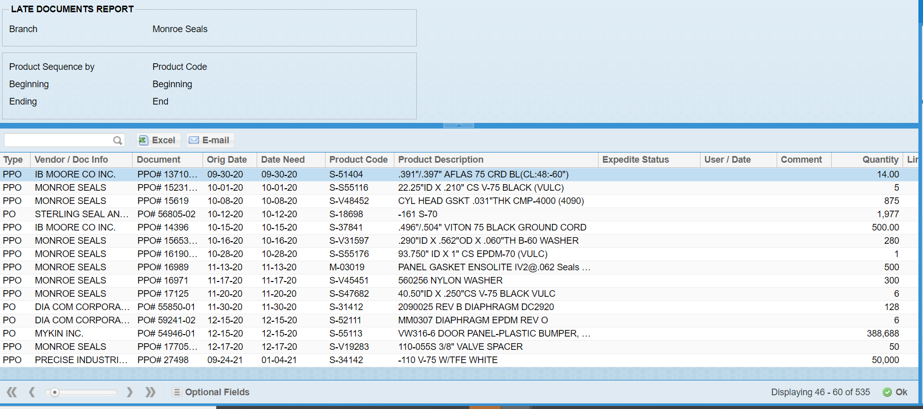

The Late Documents Report is designed to help you identify any late or potentially late products. Once a Product on the Late Documents Report has been identified as a product that you would like to expedite double click or enter on the line. If you would like to view the open activity for the Product you can view the Open Documents Inquiry under Options. The screen below shows the open documents for the product code that you have chosen. After clicking on open documents from that screen you will see the below screen

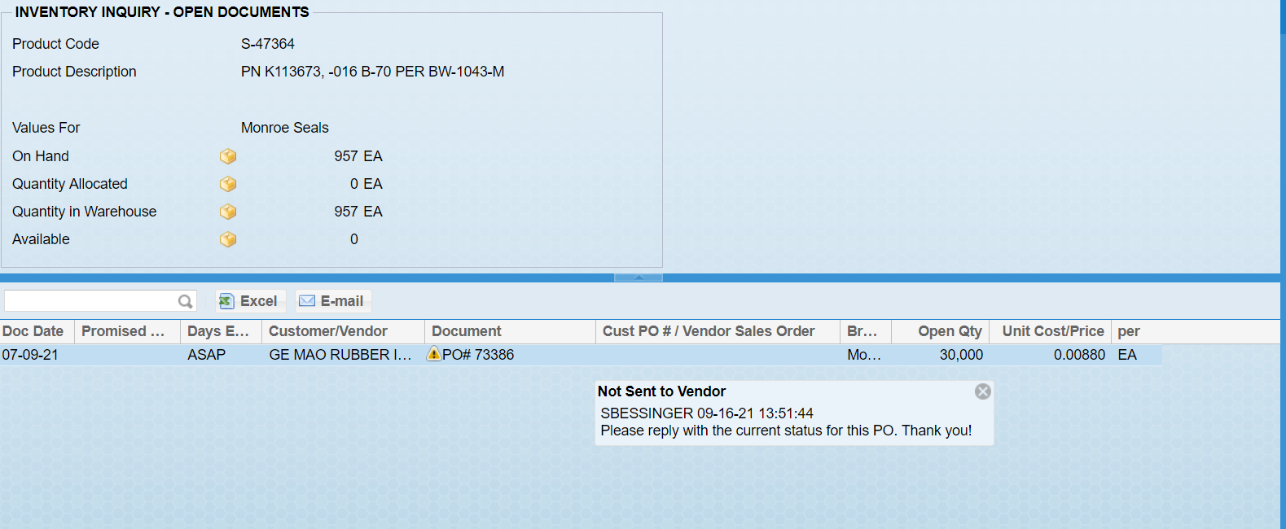

The escape key or OK will bring you back to the late documents report.
The screen below shows the result of double clicking the Purchase Order you would like to expedite. The Enter & Edit Expedite Request-Expedite Detail will allow you to select a requested Expedite Date that you will send to your vendor. The ability to enter comments that you would like to print on your Expedite request is also an option.

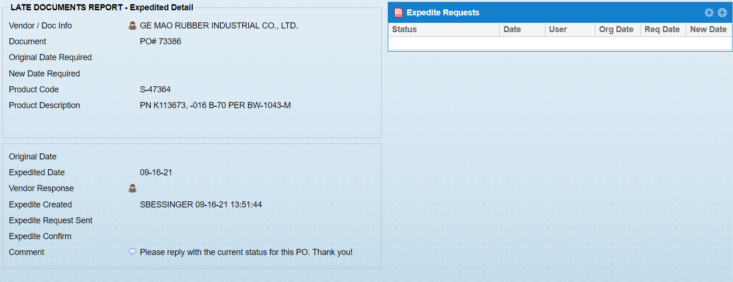

When you are finished selecting the parts you would like to send expedite requests for you will see a list of the documents you have chosen to expedite. If you hover over the yellow icon, you will see that these are documents that you have selected to expedite but have not yet been sent to the vendors. The red exclamation point next to the Type shows items that are awaiting vendor response to the expedite request.

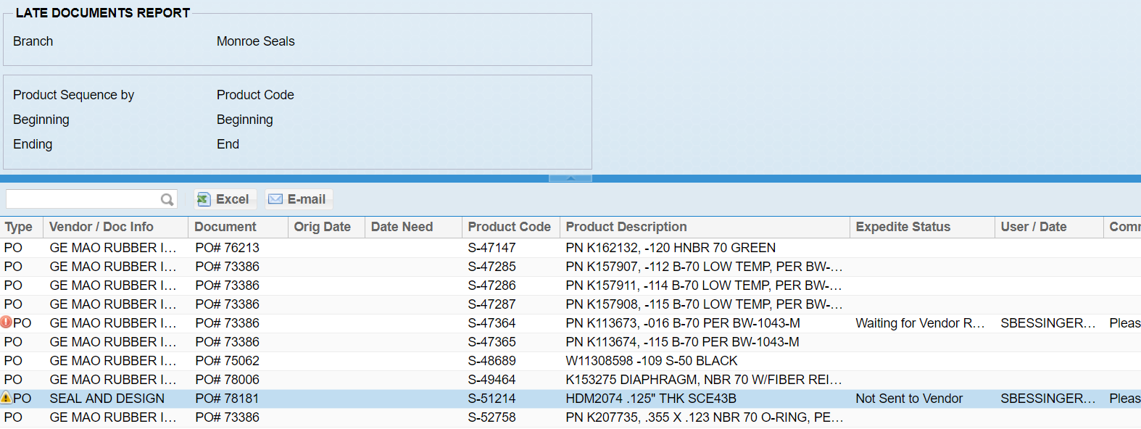

The next step in the expedite documents process is to send your expedite requests. This is done by clicking on Send Expedite Requests shown below. It is from this menu item that you can select whether you would like to print/fax/email your expedite requests to your vendor. We have found it is sometimes quicker and easier to contact the vendor manually, by direct e-mail or phone.

Please note that each branch will need to have TBE customize their form for them. The standard form looks exactly like the purchase order that was originally sent. This causes confusion at the vendor. They do not know that we are trying to expedite, it appears like we are placing a new PO and there is the chance of our PO being duplicated. Have your branch specific form customized to state that it is a “P.O. Status Check” and the words “Do Not Duplicate” in the body.

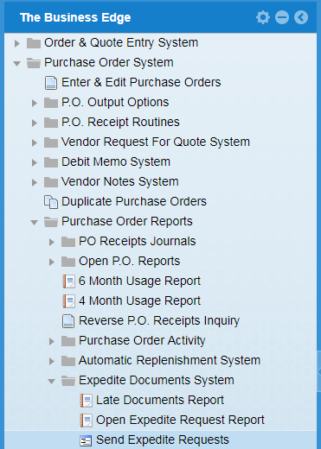

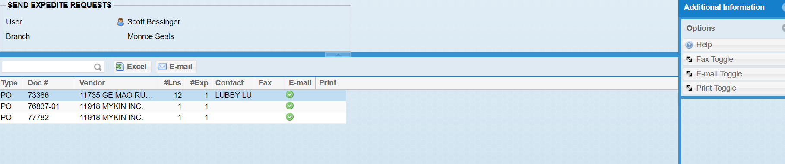

You can choose to send out your expedite request one by one or in bulk. I have found that if the original PO was entered before the vendor contact and e-mail address has been entered, you cannot e-mail those requests. In this case, you cannot e-mail in bulk as the ones without vendor e-mail addresses must be printed.

To send them individually, double click on the line and you will see the below screen

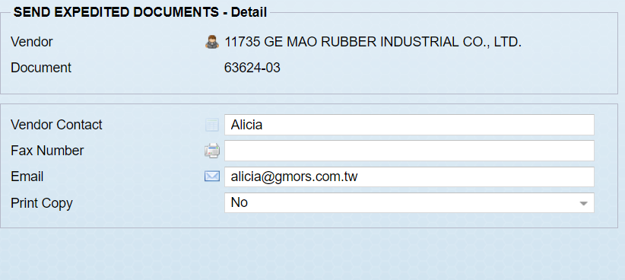

Hit okay and your request will be e-mailed to the vendor contact and e-mail address specified.

To send all your requests at once, just hit OK in the above “Send Expedite Requests” screen and you will get the next screen, as per below

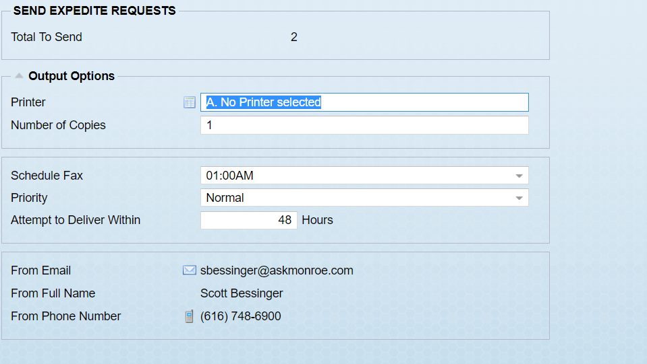

Set your output options and hit OK in the bottom corner. The requests will be sent at the time specified.

Once your expedite requests are sent to your vendors you can monitor your open expedite requests that have not yet been confirmed by your vendor by running the Expedited Documents not Confirmed report below. This report is generated by user as seen below:
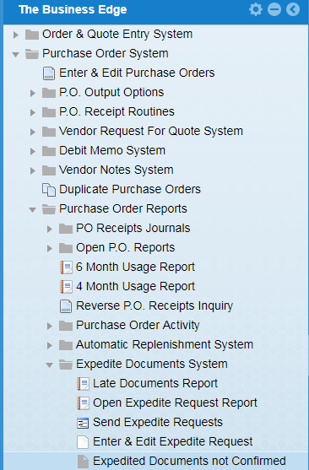

The Expedite Documents not Confirmed can be run by User. The results shown below are any expedite requests that have not been confirmed by your vendors for a specific user. This report allows you to double click on the line to enter your confirmed date once you receive it from your vendor.

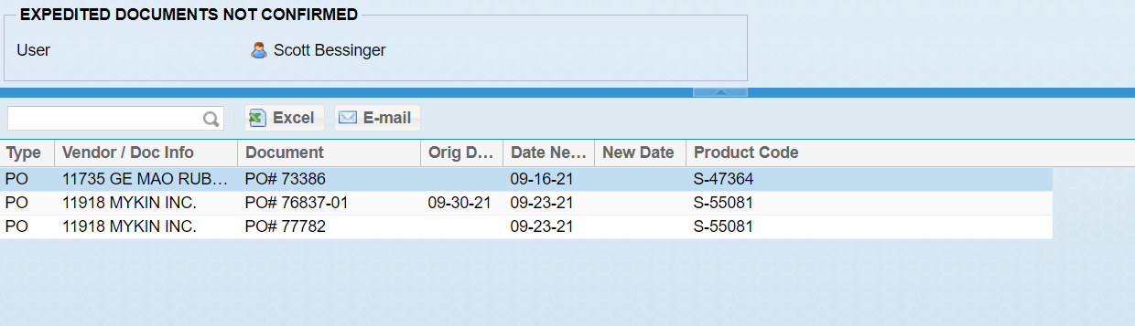

Once you choose the Purchase Order you would like to add a confirmed expedite request on you can double click the Purchase Order from the list, then enter your confirmed expedite date and any comments from your vendor.

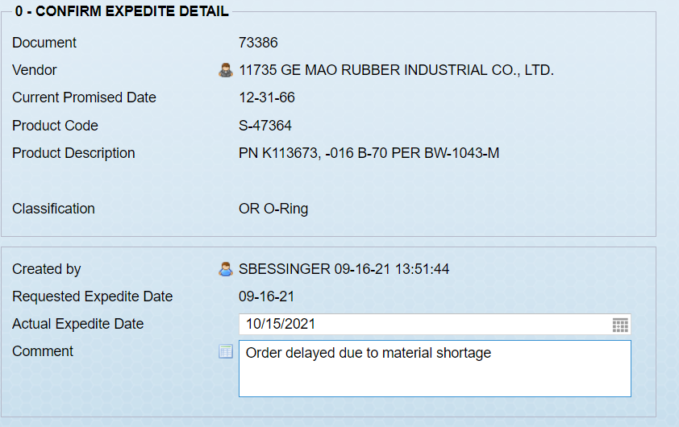

The Expedite Documents System contains several reports to help you track and monitor your inventory.
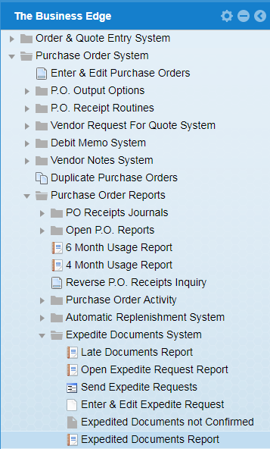

The Expedited Documents Report shown below will show you any Purchase Orders/Processing Purchase Orders that are Open, Sent and Confirmed.

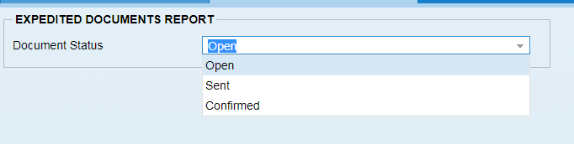
The Expedited Documents Report will allow you to Clear your document’s confirmed status when you run the report to show only documents that have been confirmed by clicking on Clear Confirm Status on the righthand side menu.

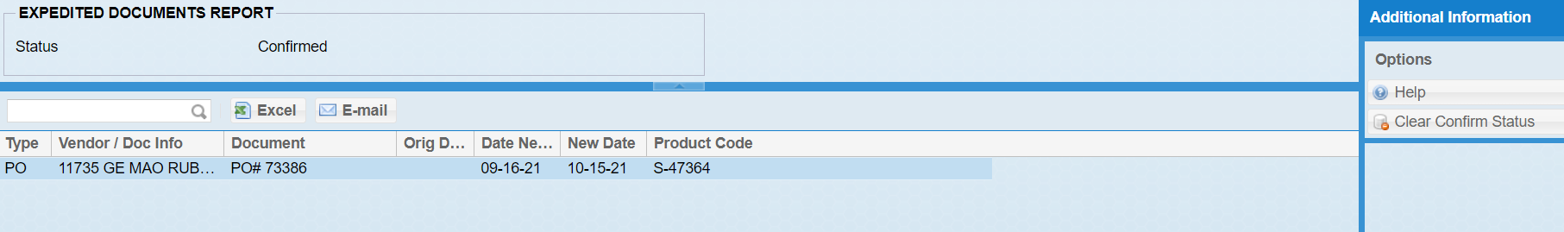

There is also a function that will allow you to manually create and/or edit an expedite request related to a Purchase Order detail line

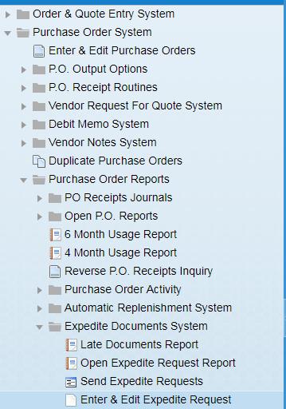

Once you have your responses back from your suppliers, first go back and re-confirm these purchase orders following the TBE PO Confirmation Procedure. Then if you find the parts will be more than one week later than the original promise date, you can either pass that information on to the account manager for the customer expecting the parts, or you can follow the TBE Customer Sales Order Acknowledgement procedure and have order entry/customer service/sales re-acknowledge the order with the new date, adding a note explaining the reason the parts will be late.

