Opportunity Management Process
- Enter Opportunity via E&E Orders
  - Use for all Opportunities of $1,000 or more
  - Utilize Opportunity Box found on first or last page of E&E Orders
    - 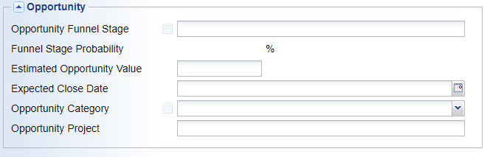
  - Choose Opportunity Funnel Stage
    - Descriptions of each stage shown on last page of this document
  - Enter Estimated Opportunity Value
    - Enter in the true value of the opportunity
      - For OEM customer with consistent usage enter the estimated annual volume of the project.
        - Example: Quoted customer 100pcs of $10 part, but they buy 100pcs every two months, enter $6000 as estimated opportunity value
      - For one-time projects enter the total value of the project
  - Choose an expected closed date
    - Date you expect to receive an order for this project. Base this on production quantity order, not sample or initial prototype orders.
  - Choose Opportunity Category
    - Pick closest product category to the parts you are quoting
  - Enter Opportunity Project
    - Enter the name of the project if the customer has provided one, name of the equipment our products are going on, or the name of the products we are providing. Keep this brief no more than 4 words.
    - Examples:
      - Opportunity Category: Casters
        - Opportunity Project: Pace Medical Bed
      - Opportunity Category: Industrial Fasteners
        - Opportunity Project: Trailer Mfg.
      - Opportunity Category: Material Handling
        - Opportunity Project: Pallet Racking
- Update or Enter New opportunity via E&E CRM Action
  - While working on your CRM Actions you can now view, update, and enter a new opportunity for that specific customer.
  - View open opportunities
    - While updating a CRM Action you can view that customer’s open opportunities on the right pane in a window labeled “Open Opportunities”
    - If you do not see this, go to Optional Information on the bottom left corner and make sure there is a check in the box for Open Opportunities.
      - 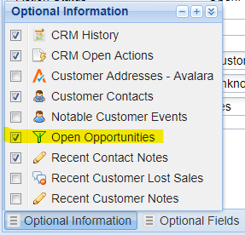
  - Update Opportunity
    - To update an existing opportunity, you can click the “+” sign on the open opportunity window.
    - Click on the opportunity you want to update then make necessary changes and click OK.
      - Example: Customer has reviewed quote on project they are bidding and informed us that if they get the order we will too. Update Funnel Stage from “Reviewing – Bid Project” to “Accepted – Bid Project”.
  - Create New Opportunity
    - You can create a New Opportunity by clicking on the “Create Opportunity” icon located on the far right under Options. Then click on New Line
      - 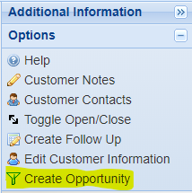
      - 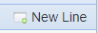
    - Once you click New Line you can fill out the Opportunity information (Stage, Value, Close Date) and hit OK. This will essentially create a new quote in the system without any line items.
      - If you do want to enter line items to quote go to the options section on the right-hand side and click on Detail Lines. This will allow you to enter the parts you want to quote.
        - 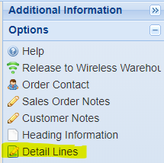

- Review and Update Open Opportunities Weekly
  - Go to Salesperson Inquiry
  - Open Opportunities by clicking the + sign under Recent Salesperson Open Opportunities or click on Opportunities in the Additional Information section.
    - 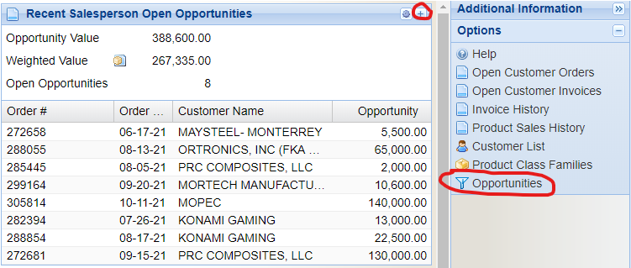
  - Choose an open ended date range like 1/1/2001 to 12/31/49
  - Choose “No” to include open opportunities
  - Leave “Yes” on only show recent items
    - 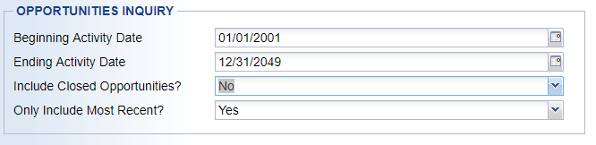
  - Hit OK and you will see all your open opportunities
  - You can update each opportunity by double clicking on the opportunity. This will allow you to edit opportunity stage, value, or expected close date.
    - 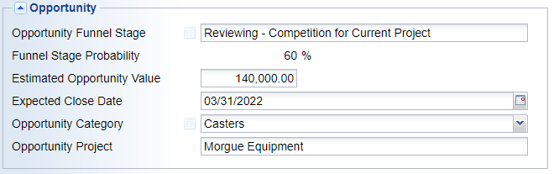
    - Once updated click OK
  - Please follow the same procedure for all open opportunities that need to be updated.
- Opportunities can also be reviewed and updated via Customer Inquiry under Additional Information > Financial History > Opportunities
  - 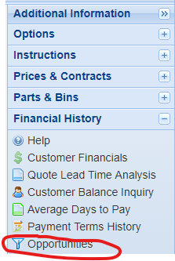

Description of Opportunity Stages
Open – 10%
We’ve identified an opportunity to supply product to the customer.
Quoted – 20%
We’ve provided an initial quote and have not received any feedback.
Quoted – reviewing – bid project – 25%
Customer has reviewed the quote and provided feedback that we are being considered for an order if they are awarded the project.
Quoted – accepted – bid project – 30%
Customer has reviewed quote, provided feedback that we will receive an order if they are awarded the project. Our quote is part of their quote.
Quoted – reviewing – competition for planned project – 35%
Customer has reviewed the quote and provided feedback that we are being considered for an upcoming project or new business.
Quoted – reviewing – competition for current project – 60%
Customer has reviewed our quote and provided feedback that we are being considered to replace their current supplier.
Quoted – accepted – planned project – 75%
Customer has reviewed quote, provided feedback that we will receive an order if the project goes through as planned.
Quoted – accepted – current project – 95%
Customer has reviewed quote, provided feedback that we will receive an order, just waiting for order to be received. We are expecting to replace their current supplier.
Closed Lost- Competitor price – 0%
Lost opportunity due to competitor’s pricing.
Closed Lost- Competitor Solution – 0%
Customer choose competitor’s solution over ours.
Closed Lost- Cancelled- 0%
The project was cancelled by the customer, or the customer used our quote on their bid, but they did not win the project.
Closed Lost- Stock/Lead Time- 0%
Lost opportunity due to not having stock of standard item or the lead time for item did not meet their needs.
Closed Won- Received Order- 100%
Closed- Budgetary Purposes Only
This can be used to close a quote which is for budgetary purposes only, for example when submitting a price increase to existing customer for parts they already purchase from us.

